1. A 0.5 kg baseball has 100 J of kinetic energy as it crosses home plate. What is the velocity of the baseball?
• 45 m/s
• 10 m/s
• 200 m/s
• 25 m/s
• 20 m/s
• 14.1 m/s
Answer:

2. If a moving vehicle triples its velocity from 10 m/s to 30 m/s, by what factor does its kinetic energy (KE) increase?
• It triples (3 times greater)
• It increases by 27 times
• It increases by 9 times (3 × 3)
• It increases by 6 times
• It remains completely unchanged
• It doubles (2 times greater)
Answer:

3. Consider two skydivers, Diver X (m = 60 kg) and Diver Y (m = 120 kg), both standing inside an airplane ready to jump at an altitude of 3,000 meters above ground level.
How does the gravitational potential energy (GPE) of Diver Y compare to Diver X before jumping?
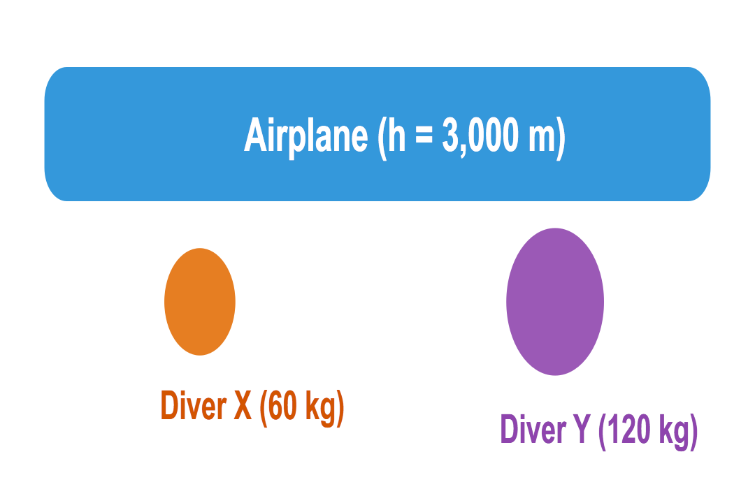
• Neither diver has GPE until they begin falling.
• Diver Y has four times the GPE of Diver X.
• Diver Y has twice (double) the GPE of Diver X because GPE is directly proportional to mass.
• Diver Y has less GPE because heavier objects experience less gravity.
• Diver Y has half the GPE of Diver X.
• Diver Y has exactly the same GPE because they are at the same height.
Answer:

4. Examine the simple pendulum swinging between positions 1, 2, and 3 without air resistance:
Which statement correctly describes the energy transformation at Position 2?
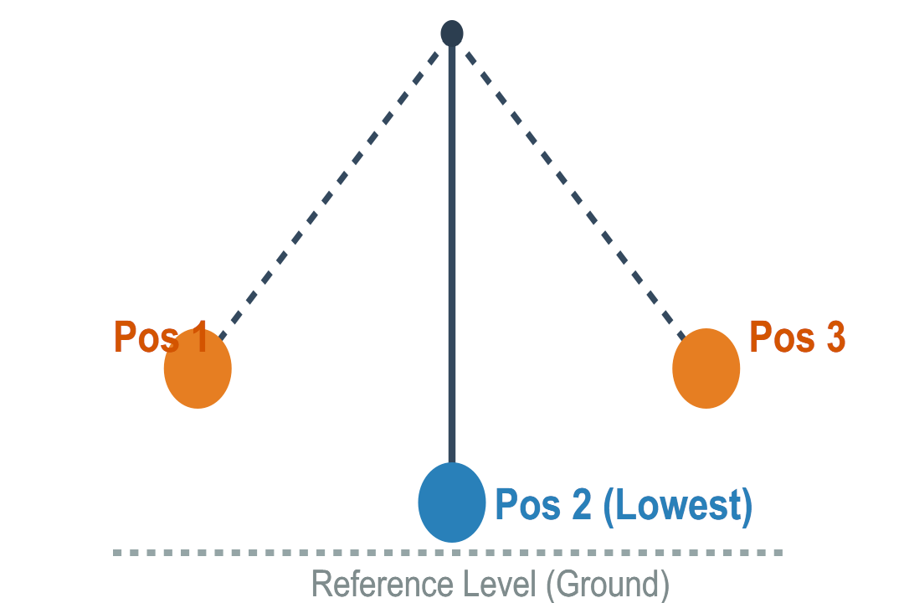
• GPE has increased compared to Position 1.
• Both KE and GPE are equal to zero.
• The pendulum has stopped moving entirely.
• KE is at its maximum and GPE is at its minimum.
• GPE is at its maximum and IE is at its minimum.
• Total mechanical energy is doubled at Position 2.
Answer:

5. A student compresses a spring launcher horizontally to propel a 0.2 kg steel ball along a smooth, level floor. If the released spring transfers 3.6 J of elastic potential energy entirely into kinetic energy of the ball, what speed does the ball attain?
• 3.6 m/s
• 4.9 m/s
• 6.0 m/s
• 12.0 m/s
• 36.0 m/s
• 1.8 m/s
Answer:

6. A 2 kg brick rests on top of a 5-meter-high scaffolding. Using g = 9.8 m/s², what is the gravitational potential energy (GPE) of the brick relative to the ground?
• 20 J
• 196 J
• 10 J
• 490 J
• 49 J
• 98 J
Answer:

7. A crane lifts a 250 kg steel beam straight up, giving it 24,500 J of gravitational potential energy. Taking g = 9.8 m/s², how high above the ground was the beam lifted?
• 10 meters
• 8.0 meters
• 5.0 meters
• 2.5 meters
• 25 meters
• 7.5 meters
Answer:

8. A remote-controlled toy race car with a mass of 1.5 kg drives down a straight track at a constant speed of 4 m/s. What is its kinetic energy (KE)?
• 3 J
• 6 J
• 24 J
• 12 J
• 48 J
• 18.5 J
Answer:

9. A 4 kg bowling ball is dropped from rest from the top of a 20-meter cliff. Neglecting air resistance and using g = 10 m/s² for simplicity, what is the velocity of the bowling ball just before it strikes the ground?
• 5 m/s
• 40 m/s
• 20 m/s
• 400 m/s
• 10 m/s
• 200 m/s
Answer:

10. An 800 kg roller coaster cart sits momentarily at rest at Point A (height = 20 m) before rolling down a frictionless track to Point B at ground level (height = 0 m).
Assuming g = 9.8 m/s² and zero energy loss to friction, what is the kinetic energy of the cart when it reaches Point B?
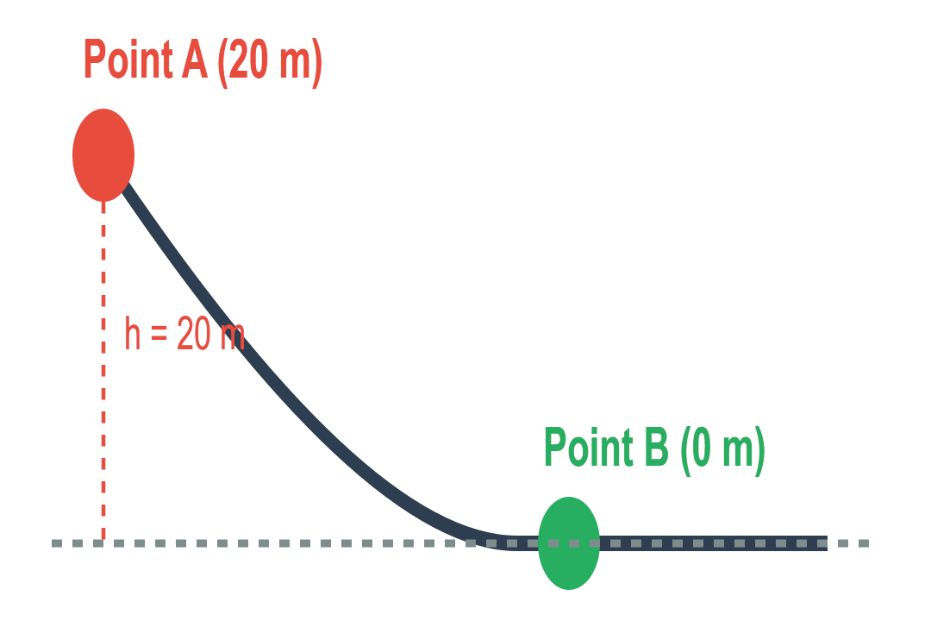
• 312,400 J
• 0 J
• 78,100 J
• 38,400 J
• 16,000 J
• 156,200 J
Answer:

